AULA: ____________________________________
NOMBRE: __________________________________
APELLIDOS: _________________________________
CURSO: _________ASIGNATURA: ___________
Las tareas podrán entregarse en formato digital (Word o PDF) a ingles3@cepaantoniogala.es.Los archivos deben estar nombrados de la siguiente manera:
AULA.NOMBRE Y APELIDOS.CURSO.ASIGNATURA
Los archivos que no sean nombrados de esta manera serán devueltos y podrán reenviarse debidamente nombrados dentro del plazo establecido.
También podrán ser entregados en mano a los profesores de distancia
La fecha máxima de entrega de las tareas sea hasta EL 27 DE MAYO

Modulo II
Tema 3: Women in history
- Write the verbs in brackets in the simple past:
1. I ____________ (buy) the car last year.
2. Peter ______________ (come) here three years ago.
3. They ________________(see) a good film yesterday.
4. Mary ____________________(clean )the house yesterday morning.
5. They _______________________(stop) talking when the teacher arrived.
6. I _____________________(buy) my house three years ago.
7. They _____________________(go) to Europe last month.
8. We ___________________________ (eat) fish last Friday.
9. The students _____________________(have ) a test last week.
10. My parents ______________________(be ) on holiday last summer

- Write questions for the sentences above.
- ___________________________________________
- ___________________________________________
- ___________________________________________
- ___________________________________________
- ___________________________________________
- ___________________________________________
- ___________________________________________
- ___________________________________________
- ___________________________________________
- ___________________________________________
3. Answer the questions using the information given in parenthesis, as in the example:
Did you go by bus last night? (go by taxi.)
No, I didn’t go by bus. I went by taxi
1. Did they watch TV last night? (Listen to the radio)
2. Did she eat fish for dinner? (Chicken)
3. Did Peter walk to the park? (take a bus)
4. Did he read a book in English? (French)
5. Did you see Mary last Sunday? (yesterday)
4. Complete the following sentences using the verbs given in parenthesis in the Past Continuous:
- The sun ____________________(shine) when Peter got up this morning.
- The students ___________________(play ) rugby whenit began to rain.
- We ______________________________(cross) the road when the accident happened.
- We _______________________(have ) dinner when the light went out last night.
- Mrs. Brown _______________________(do the shopping when she had an accident.
5. Use the past simple or past continuous to complete the sentences
- I ____________________(have) a shower when the fire started.
- Peter had the accident while he _______________(drive) home.
- While Mary was sleeping, the children ______________________ (chat).
- What were the children doing when the teacher ___________________ (arrive).
- When Peter arrived yesterday I was just listening__________________ ( listen) to music.

Tema 4: Directions
1. Find places on the map. Read the sentences and match them with the places in the map:
1. The toy shop is between the police station and the swimming pool. _____
2. The park is opposite the police station. It is also opposite the ZOO. ______
3. John’s house is next to Fiona’s house.______
4. The pub is next to the drug store. ______
5. The theatre is between the supermarket and the bowling alley. ______
6. The bowling alley is opposite Adam’s house. ______
7. The university is behind the petrol station. It is also behind the bakery. ______
8. The night club is between the pub and the sweet shop. ______
9. Mary’s house is near the university. It is next to the bakery. ______
10. Susan lives near the petrol station. ______
11. The school is behind the florist. _______
12. The florist is next to the hardware store. ________

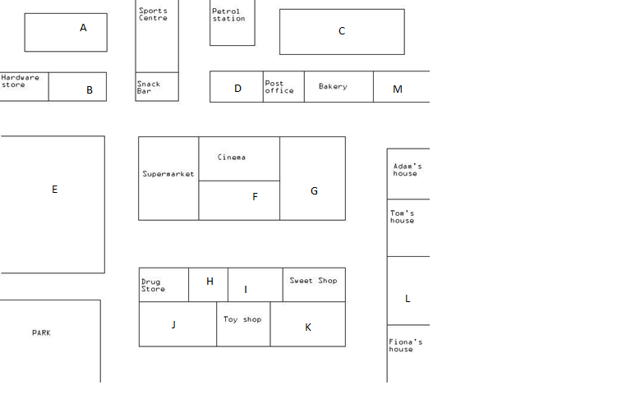
2. Say - how can you get to…
- the park from Adam’s house
- the supermarket from Fiona’s house
- the school from the toy shop
- the police station from Mary’s house
- the swimming pool from the florist

MODULO III

BLOQUE 9: Aspectos socioculturales y consciencia sociocultural
Tema 5: Regulations | - Obligación y prohibición: MUST, HAVE TO, DON’T HAVE TO, MUSTN’T  - Cuantificadores: SOME, ANY, NO, MUCH, MANY, A LOT OF.

Tema 5: Regulations
1. Complete with mustn’t or don’t have to
- It is forbidden. You ______________ do that.
- You ______________ ask my permission. You can do what you want.
- You _____________ speak to the driver when the bus is moving. It's dangerous.
- Help yourself to anything you want. You _____________ ask.
- You ______________ park here. There is a double yellow line.
- Pay me back when you can. You ______________ do it immediately.
- It's optional. We ______________ to go if you don't want to.
- I'll tell you a secret. You _____________ tell anybody else. Promise?
- Whatever you do, you ____________ click with the right mouse button or the program will crash.
- Be on time. You _____________ be late or we will leave without you.
- He's a millionaire. He _______________ work but he does because he enjoys it.
- I like Saturdays because I ______________ go to work.
- This is very important. You ______________ forget what I said.

1. Insert a/an before each countable noun. Put an (x) before an uncountable noun.

a) ____ water b) ____ egg c) ____ cheese
d)____ meat e) ____ banana f) ___ hamburger
g) ____ meal h) ____ fish i) ____ tea
j) ____ cup k) ____ sugar l) ____ apple
m) ___ rice n) ____ bread o) ____ orange
p) _____ sandwich q) ____ cookie r) ____ sausage

Some / Any

- There are _____________ students in the dining room.
- There aren’t _____________ interesting people at the meeting.
- Are there _____________ tomatoes ?
- Have you got ___________ bread?
- There is_______________ sugar on the table.
- Are there ____________ pretty girls in the class?
- I don’t think I have ____________ milk l
- Julie can speak _____________ French but she can’t speak ____________ Spanish.
- I can lend you _____________ money if you want.
- We haven’t got ____________ eggs.

A LOT OF; MANY; MUCH

- Do they spend_______ time playing football?
- I don’t take___________ sugar in my tea.
- My grandma has got_______ hamsters.
- Do they need _________ time to paint the room?
- Sorry, I haven’t________ money for you.
- Are there_______ things to buy?
- There are________ questions he can’t answer.
- Did you visit______ countries?
- I usually eat_________ vegetables.
- There weren’t ________people at the bus stop.
- She knows _________foreign people.
- There were_________ tourists in Rome.
- Are there ________ vegetarian dishes in the restaurant?
- There is _______ sand here.

HOW MUCH AND HOW MANY

- We need some tea. ______________ do we need?
- We need some eggs. _____________ do we need?
- We need some paper. ___________ do we need?
- We need some money. __________ do we need?
- ___________ cigarettes do you smoke a day?
- ____________ work have you got to do?
- ____________ sleep did you get last night?
- ____________ children have you got?
- ____________ English grammar do you know?
- ____________ American people do you know?

