NOMBRE____________________________________________
NO OLVIDES PONER EL AULA AL QUE PERTENECES ADEMÁS DE TU NOMBRE EN EL ARCHIVO QUE ENVIES. Muchas gracias
AMBITO DE LA COMUNICACIÓN. INGLES MODULO
BLOQUE 8: Análisis y reflexión sobre la lengua
Tema 3: Women in history | - Comparación entre el pasado simple y el pasado continuo.
Tema 4: Directions | - Excuse me, sir/madam. How do I get to…?  - Preposiciones de lugar

TEMA 3 WOMEN IN HISTORY

PASADO SIMPLE DE LOS VERBOS REGULARES

- Escribe los verbos entre paréntesis en pasado simple.
- My uncle ----------------------------------- ( visit ) us this weekend.
- I -------------------------------- ( listen ) to music with my friends.
- We ------------------------------- ( study ) hard for the exam. So, we ----- ( answer )all the questions.
- I -------------------------- ( wait ) for the school bus but it --------------------------- ( not-come ).
- Karen ---------------------------------- ( ask ) for help to finish her homework.
- ------------------- you --------------------------- ( invite ) them to your party last week.
- Yesterday night, somebody ------------------ ( knock ) at the door. But I --------------------- ( not-open ) it.
- The students ---------------------------------- ( walk ) down the street with their teachers.
- Something strange --------------------------------------- ( happen ) last night.
- Tom ------------------------------------- ( check ) his answers.
- The postman ----------------------------------- ( deliver ) the letters.
- We ------------------------------------ ( live ) in Madrid three years ago.
- Helen -------------------------------- ( not-study ) for the exam and she ---------------------- ( fail )
- Cambia las siguientes frases a negativas y preguntas:
1) Clare played tennis this weekend. ( - ) ------------------------------------.
2) David washed his car on Saturday. ( - ) -----------------------------------.

3) Kate finished her homework. ( ? ) ----------------------------------------.
4) All the students answered the questions. (- ) -----------------------------------.
5) Marta waited for the bus. (- ) -------------------------------.
6) Elisa called Sue to go out. ( ? ) ------------------------------.
7) John watched TV all the day. ( ? ) ----------------------------.
8) Alex washed the dishes. ( ? ) --------------------------------
9) Dorothy invited me to her birthday party. ( - ) -------------------------------------------.
10) Julia cleaned the entire house this morning. ( ? ) -------------------------------------------.
PASADO SIMPLE DE LOS VERBOS IRREGULARES
3. Escribe los verbos entre paréntesis en pasado simple
1. Daisy (bring) some chocolates to the birthday party.
2. I (hear) a new song on the radio.
3. Peter (read) three books last week.
4. The Smiths (speak) Italian to the waitress.
5. Peter (understand) during the class, but now he doesn't understand.
6. My mother (forget) to buy some milk.
7. Susan (have) a baby in August.
8. We (lose) our keys last Friday.
9. They (swim) 500m yesterday afternoon.
10. I (give) my mother a CD for her birthday.
11. At the age of 23, she (become) a teacher.
12. I (know) the answer yesterday.
13. Peter (tell) me that he lived in New York.
14. We (lend) John €200.
15. She (drink) too much coffee yesterday.
PASADO CONTINUO
4. Escribe el pasado continuo de los verbos entre parentesis.
1) They ___________________________ in the lake yesterday afternoon. (swim)
2) He ___________________________ on the coach. (sleep)
3) I ___________________________ a book. (read)
4) We ___________________________ breakfast at 7 am yesterday. (have)
5) Sarah ___________________________ the fence. (paint)
6) The kids ___________________________ the picture. (colour)
7) You ___________________________ about the accident. (talk)
8) The dog ___________________________ all last night. (bark)
9) We ___________________________ to the radio yesterday morning. (listen)
10) Pete ___________________________ his car last weekend. (wash)

PASADO SIMPLE O PASADO CONTINUO
5. Elige la forma adecuada en cada frase.
1 Jim was breaking / broke his leg while he was playing golf.
2 When I arrived, I was going / went into the kitchen.
3 I was seeing / saw an old friend while I was waiting for the bus.
4 While I had / was having a bath, the phone rang.
5 Anna was meeting / met Judy while she was doing some shopping.
6 While Joe was cooking / cooked lunch, Clare arrived.
7 Someone was taking / took Peter’s bag while he was making a phone call.
8 While Maria was walking home, she was loosing / lost her money.

6. Escribe el pasado simple o el pasado continuo para completar estas frases.
1 When the teacher ___________________(come) into the room, two boys ____________(play) football.
2 Peter __________________(turn on) the TV, but nothing _________________(happen).
3 When Helen ________________(walk) to school, she ______________(see) the old man again.
4 While we _________________(run) in the park, Mary __________________(fall over).
5 At 7.00 Tony _______________(get) out of bed, and __________________(go) into the bathroom.
6 While Kate __________________(drink) some milk, she _______________(drop) the glass.
7 While I _________________(listen) to music, I _______________(hear) the doorbell

TEMA 4: DIRECTIONS
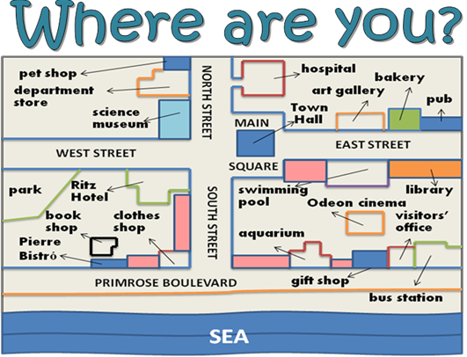
- Mira el mapa y complete las frases con una preposición de lugar:
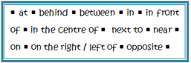

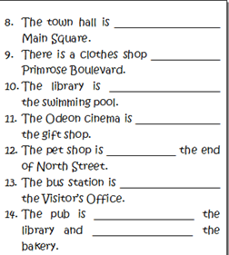
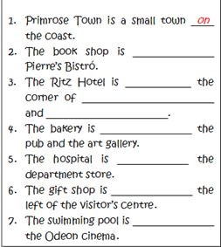

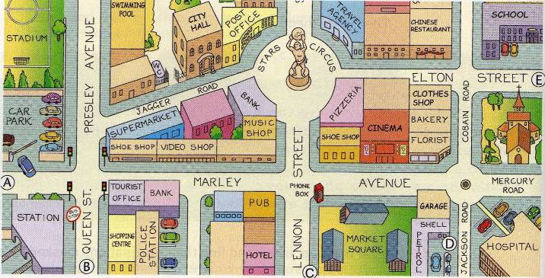
2. True (t) or False (f)?
1. The stadium is opposite the swimming-pool
2. The cinema is between the shoe shop and the florist
3. The tourist office is next to the hospital
4. The school is on Elton Street
5. There are 4 banks
6. The florist is next to the bakery
7. There is a pub at the corner of Marley Avenue and Queen Street
8. The city hall is beside the station

3. Mirando el mapa anterior. Explica en inglés como darías las direcciones que te preguntan.
Can you tell me the way to the post office? (you are at the hospital)
_____________________________________________________________________________
Where is the swimming-pool?(you are having lunch at the pizzeria)
_____________________________________________________________________________
Can you tell me the way to the school?(you are at the police station)
_____________________________________________________________________________
Excuse me, how can I get to the stadium?(you are at school)

